Smart Liquid Level Controller Using Arduino with SMS Alert

FIROZ. D. CHOWKI, KANHAIYA.V.DEHADRAY, SUDARSHAN.T.AHIRE, NIKHIL KUMAR.GAIKWAD.
(Under Graduates in Dipoma Mechanical ENGG, JSPM’s Jayawantarao Sawant Polytechnic Hadapsar Pune.411028).

Prof.A.S.NIKHADE.
(Sr. Lecturer in Mechanical Engineering Department, JSPM’s Jayawantarao Sawant Polytechnic Hadapsar Pune.-411028)

Abstract
Water is one of the most important resources on earth. Almost 70% of earth’s surface is covered with water from which 2% is fresh water. Now a days everyone has a busy schedule which consumes the time for checking the water level at every instance. The project presents an idea of “Smart Liquid Level Controller Using Arduino with an SMS Alert”. This project was carried out to make user’s life easy and time saving. The project includes the components such as relay and Arduino for controlling the pump to avoid the wastage of water.

Keywords: Ultrasonic Sensor, Arduino, GSM, Relay, Water Pump, Display, etc.

1. Introduction

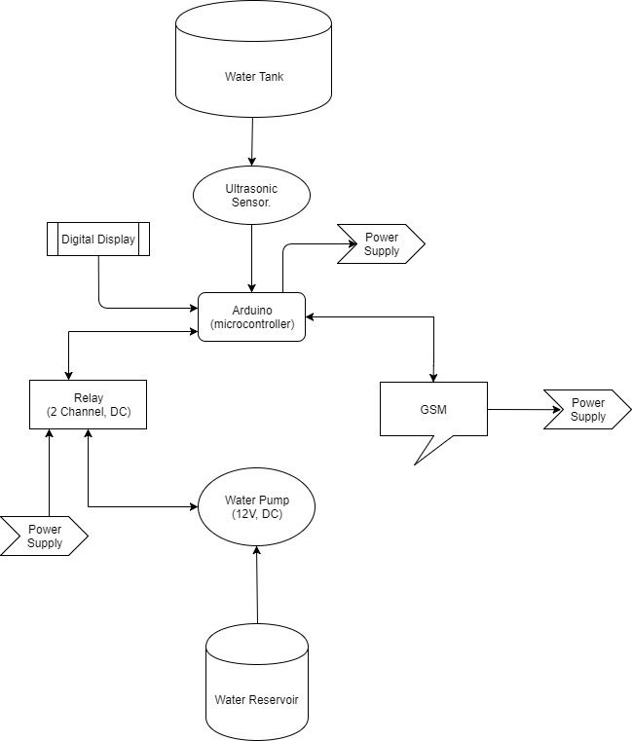
Automation of smart system is the essence of today's world. the “Smart Liquid Level Controller Using Arduino with an SMS Alert”, can be an appropriate example for the smart system. In the recent times due to to the huge scarcity of water resources frequent droughts have been occurring, due to which the various initiatives have been undertaken, out of which one is the system that will serve to save the water that is being wasted in the households, agriculture's and in different industries . some of the hazardous incidents such as the boiler bursts due to the lowering of the water level also can be avoided, which is also controlled by using this smart system.

A GSM communication system is provided which makes the system an user friendly by providing an SMS notification to the user on their mobile phones. The GSM device is used to control the liquid level by giving an SMS alert of the percentage of liquid filled into the system.

An Arduino is a Microcontroller which is programmed in programming languages like C and C++ in an Arduino software. Arduino is a device which is coded and commands the other devices such as relay, GSM, and other circuits.

The system also includes a 2-channel relay which is operated by using the arduino and acts as a circuit breaker, and controls the ON/OFF position of the pump.
Ultrasonic sensor is placed on top of the tank which senses the depth or the height of the liquid level inside the tank by using the ultrasonic waves transmission.

Simply this system is totally a mobile based system, in which the user can get notifications by just sitting at one place which reduces almost the total time consumption and efforts for a user.

2. Basic Concepts:

The components of this project which are useful to control the system in an effective manner are explained below. The arrangement of the component is arranged using flow diagram of a system as shown in the figure-01.
Basic descriptions of some parts are given below: Fig.01.: Flow diagram of a system.

A.Ultrasonic sensor:

The ultrasonic sensor is a non contact type device which uses the sound waves. There are 2 ports on the front, one port generates the ultrasonic waves like a micro speaker and other port receivers. The ultrasonic waves like a small micro phone. The liquid level is calculated, on the basis of the total time required for the sound to reflect back.
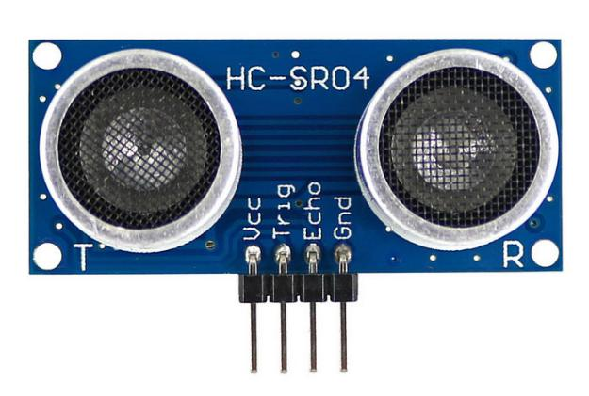
Fig.02.: Image Of Ultrasonic Sensor.

B.Arduino:

Arduino is a one type of micro controller circuit ATmega328P. It has 14 digital input and output pins, from which the 6 pins are used for output and 6 are used for the analog inputs. It has a USB connection and a power jack with a ICSP headers and the reset button. The programme is carried out in the arduino by using the arduino software in the programming languages like C and C++ .
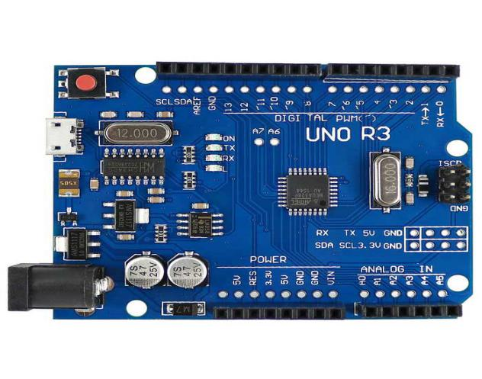
Fig .03.: Image of Arduino.

C.GSM (Global System for Mobile communication):

GSM is a standard developed by the European tele communication standards institute (ETSI) to describe the protocols for the second generation mobile devices and tablets which is further developed in third generation and fourth generation. Simply, GSM is a digital mobile telephonic system which is used widely around the world. The GSM uses the variations of the Time Divisions Multiple Axis (TDMA). It is also widely used in 3 other digital wireless telephonic technologies which are TDMA, GSM, and CDMA.
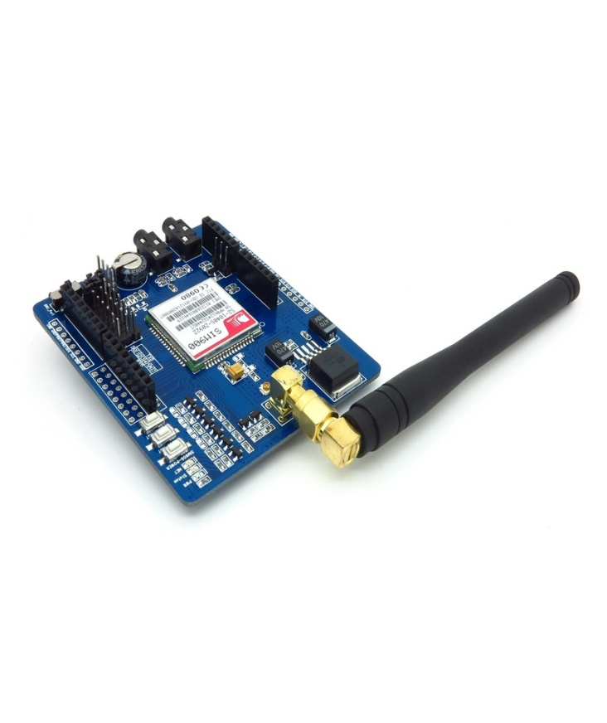
Fig.04.: Image for GSM (Global System for Mobile-communication).

D.Relay:

Relay is an electrically operated switch . Relay have 2-channels connected to the arduino, and in between the battery and the pump. The arduino commands to relay to switch-off the pump when the tank is fully filled. Simply, it acts as a circuit breaker.
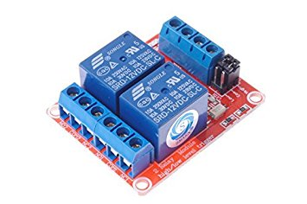
Fig.05.: image of Relay (2-channel).

E.Water pumps:

Pump is a mechanical device which converts the mechanical energy into the pressure energy. It creates the partial vacuum in the suction side and sucks the liquid which is delivered with high pressure at a required height.
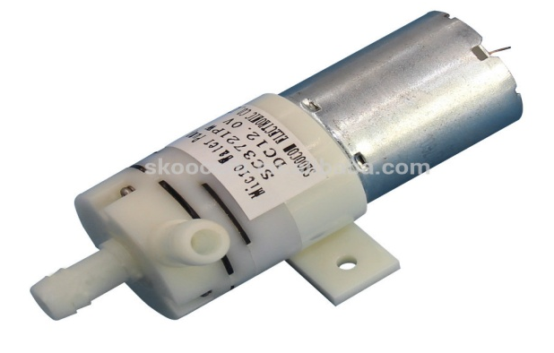
Fig.06. :Image of the 12V mini water pump.

F.LCD Display:

The LCD display is used for to indicate the percentage of liquid filled in tank. 16 x 2 LCD is named because its having 16 column and 2 rows. They are available in various combination like 8 x 2, 8 x 1, 10 x 2, 16 x 1, etc. But 16 x 2 LCD is mostly used. Hence we are preferring it for our project. It has 16 pins , an LCD is electronic module which uses liquid crystal to display the image. The LCD display is interfaced with arduino which controls the display to indicate the water level.
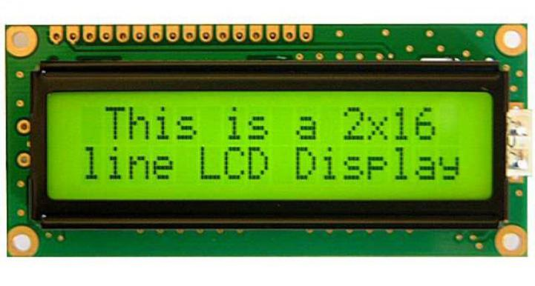
Fig.06. :Image of LCD Display.

3.Methodology:

To accomplish the process mentioned earlier, the following equipment's are needed:
- Ultra sonic sensor.
- Arduino (micro controller).
- GSM. (Global system for Mobile-communication).
- Water Pump.
- Relay.(2-channels).
- Battery Supply. (9Voltage.).
- Adapter.
- Jumper Wires.
- LCD Display.
- Other Domestic Appliances.

Steps To be Followed:

- An ultra sonic sensor is fitted at the top of inside of the water tank. The sensor detects, the percentage of water/liquid filled into an empty tank.
- This sensor is connected to the arduino which is a type of a micro controller.
- The GSM module is also connected to the arduino, which is used to send the notification of liquid level to the user using the SMS service.
- The relay provided in between water motor/pump and power supplied to switch OFF the pump , when the pump is fully filled.
- The display is interface with arduino which indicates the percentage of water level in the tank.
- All the devices are connected using the jumper wire.(male-male, male-female, female-female).
- The power supply is provided individually to the GSM, Arduino, Water pump/motor, using the battery(9V) or the DC supply.
- The whole system is represented a block diagram as shown in figure-07.

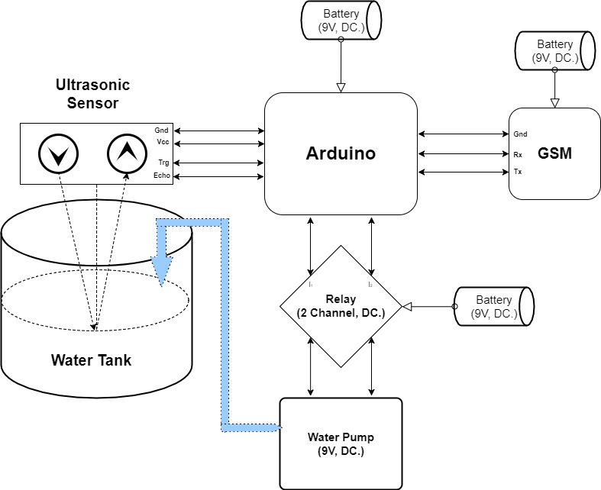
Fig.07.: Block diagram of a system.

Set-up Working:-

The water generally stored in water reservoir at bottom side, which is required lifted to top most side tank .The water from reservoir is lifted using pump, it is a mechanical device which pressurized the water and delivered to as our requirement. The 2- channel relay is provided in between Arduino and pump which acts as contact breaker between them. If liquid/ water level falls below 20% inside tank that time Arduino commands to relay to switch ON the pump as well as also commands to GSM to sends message to users or operator as “water tank was less than 20%,Water pump switched ON”. Due to this users get alert and pump switch automatically. The ultrasonic sensor fitted at top most inside the water tank which continuously updates to Arduino as the liquid level of tank in percentage.
As the liquid or water level reaches to above 80% that time Arduino commands to relay to switched OFF the pump as well as to GSM to sends the message as “water tank is 80%, water pump switched OFF”. The 16*2 LCD display is interface with Arduino which indicates the % of water filled inside the tank.

4. Applications:

- It can be widely used for the household purposes to avoid the wastage of water through the water tanks.
- It can be widely used in chemical industries to manage the liquid filled in the big tanks.
- It can be used in nuclear power plants as the water controlling systems is essential.
- It can be also used in the thermal power plants .
- It also finds a wide applications in the oil refineries industries.
- It can be used in dairy farms.
- It can be also used in water purification plant.

6. Conclusion:

It is a fact, that the large amount of liquid (water) is wasted due to the lack of well monitoring and controlling system. The automatic liquid level controller is a smart system as all process occurs automatically with a continuous updates to the operator/owner by using GSM technique that is an SMS notification system. When the tank is empty or filled with liquid (water) upto 20 percentage then the GSM sends the SMS alert to the operator/owner to switch ON the pump and when the tank is filled upto 80 percentage it will alert the operator/ owner and then if the tank is fully filled then the pump is automatically switched OFF and the SMS is send to operator/owner. Thus, our sole intention of undertaking this project is to develop a easy, effective and automatic system which can solve our liquid (water) wastage problems. We have done project successfully.

7. Experimental setup:

8.Acknowledgment:

We are very thankful to Prof. R. S. Gorde Head Of Department (HOD) To Encourage us and to have faith on us. We are also thankful to our teacher Prof. A.C.Shinde, to help us in our project to make it successful. I would also like to express my gratitude towards Professors, Lab assistant and the entire,Mechanical Department and Electronics and Tele- Communication Department of the J.S. Polytechnic Pune for their constant support and assistance in our project.

9.References:

- “Smart Water Monitoring System Using Wireless Sensor Network at Home/Office.” Publisher Ms.T.Deepiga, Ms A.Sivasankari , D.K.M College for Women(Autonomous), Vellore, Tamil Nadu, India.
- “Water Tank Monitoring and Visualization System Using Smart-Phones .“ Publisher Haesung Tak, Daegeon Kwon, Hwan-Gue Cho, Pusan National University.
- “Microcontroller Based Automated Water Level Sensing and Controlling: Design and Implementation Issue .“ Publisher S. M. Khaled Reza, Shah Ahsanuzzaman Md. Tariq, S.M. Mohsin Reza.
- “Smart Water Tank Management System for Residential Colonies Using Atmega128A Microcontroller.” Publisher Yogita Patil, Ramandeep Singh, ITM University, Gurgaon.
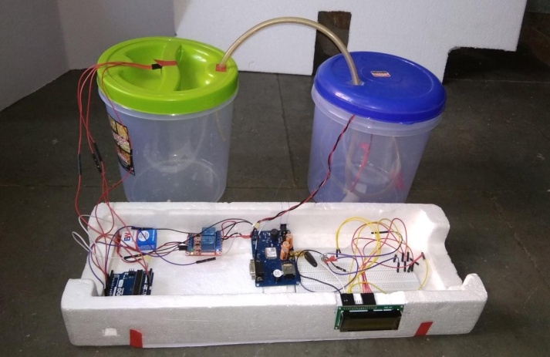
- “Android Based Smart Water Pump Controller With Water Level Detection Technique.” Publisher Prof. Souvik Paul, Mousumi Das, Anik Sau, Soumyadeep Patra, West Bengal, India.
- “Automatic Water Level Controller with Short Messaging Service (SMS) Notification.” Publisher Sanam Pudasaini, Anuj Pathak, Sukirti Dhakal, Milan Paudel, Kathmandu University, Nepal.
- “Instrumentation Devices and Systems.” Second Edition C.S.Rangon, G.R.Sarma, V.S.V.Mani. Copyright 1997 By TATA McGraw-Hill Publishing Company limited.
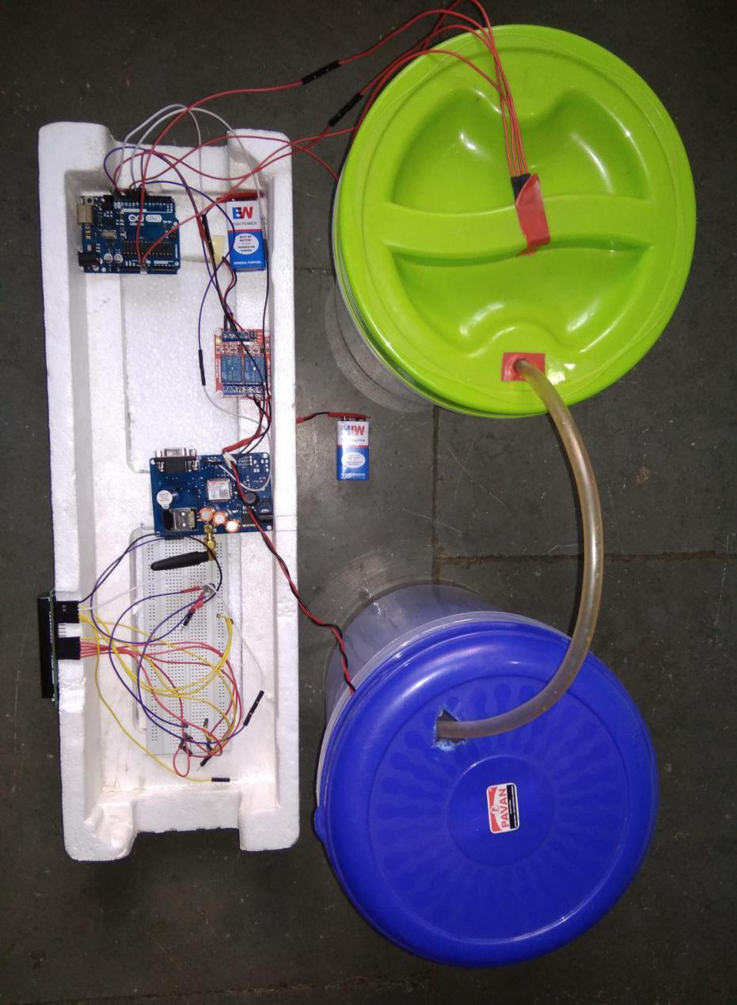
- “Wireless and Cellular Telecommunication” third Edition William C.Y.Lee copyright 1995. by TATA McGraw-Hill Publishing Company limited.
- “Programming and Customizing the 8051 Microcontroller.” Myke Predko copyright 1999 by TATA McGraw-Hill Publishing Company limited.

